OOPS:

Any real time problem can be solved if we follow OOP's Principle.

Software: Collection of programs

Program means set of instructions.

To write instructions we need to have language.

In OOPS while solving the problem

1.We need to first mark the Objects.

2.Every Object we mark should have 2 parts.

A.HAS_Part/Fileds/Attributes(Store information as variables)

B.Does-Part/Behaviours(represent them as methods).

3.To reperesent an Object,we need to have blue print of an Object.---Class

4.we use "new" keyword to create an Object for blue print.(class).

5.Every Object should always be in constant interaction.

6.Useless Object doesn't exists.

What is HAS-Part and What is Does-part of an Object represents?

HAS-Part ==>indicates what it can hold

Does-Part ==>Indicates what it ca do.

Ex: Student:

=>name,Age,Email(Variables/Identifiers)

=>play,Study,Drink(Methods)

What is blue print and how to represent it ?

In Java to represent a blueprint we have reserved word called "class"

Conventions followed by Java developers while writing a class is

a.className should be "PascalConvention"

Ex:BufferedReader,FileReader,String

b.varaibles are reperesented in "camelCase"

Ex:regNo,firstName,lastName,length

c.methods are reperesented in "camelCase"

Ex:toUpper(),toLower(),toString(),nextInt(),......

Ex:

//Blue print of Student Object

class Student{

//HAS-Part : camelCase Convention

int sid;

int age;

String name;

String address;

//Does Part: CamelCase Convention

void play(){}

void study(){}

void drink(){}

}

//To create an object in Java we use "new" keyword.

new ClassName----This will create and Object that will be mapped to some reference and that reference return type will be Class Type

ClassName ref=new ClassName();

What is Object:

Physical existence of any element we say Object.

Eg:book,Car........

BookMyShow:

Objects: person

Ticket

Cinemahall,Chair

Anything that needs to executed will be placed on RAM.

At run time to execute a program a space will be given. That we will call it as JRE(Java Run time Environment). – OS allocates this space to program to execute the program.

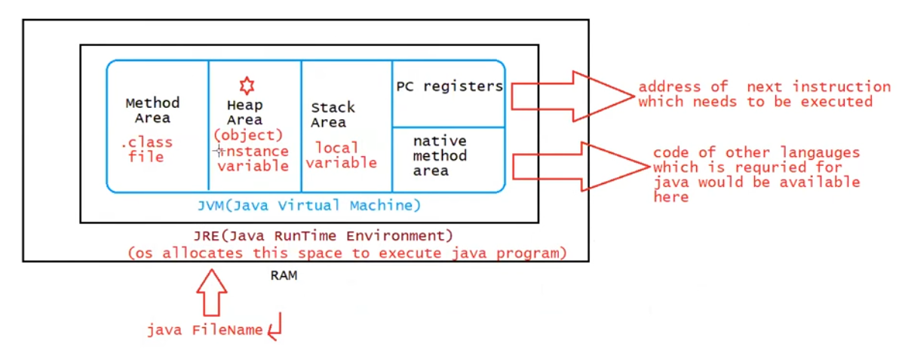

JVM Area for Execution:

* Method Area (.class/static data)
* Heap Area (Objects data/instance variables)
* Satck Area(Local variables)
* PC=Register
* Native method area

Types of variables:

Based on the type od values represented by a variable all variables are divided into 2 types.

They are:

1.Primitive variables

2.Reference variables.

Primitive variable:

Ex: int x=10

Reference variables:

Can be used to refer Objects

Ex: Student stf=new Student()

Instance variable:

If the variable is declared inside the class, but outside the methods such variables are called instance variables

Or

If the Value of the variable changes from Object to Object then such variables are called “Instance Variables.

Student std1=new Student() ; //id=07 ,name=Chinmay

Student std2=new Student() ; //id=10 ,name=sachin

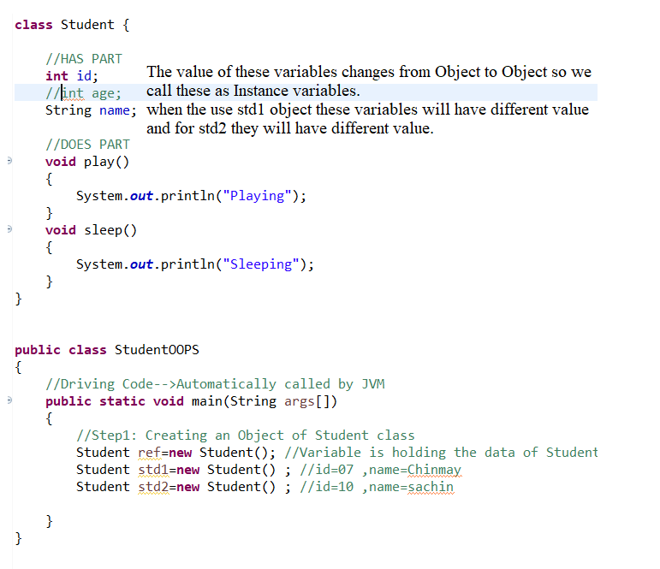

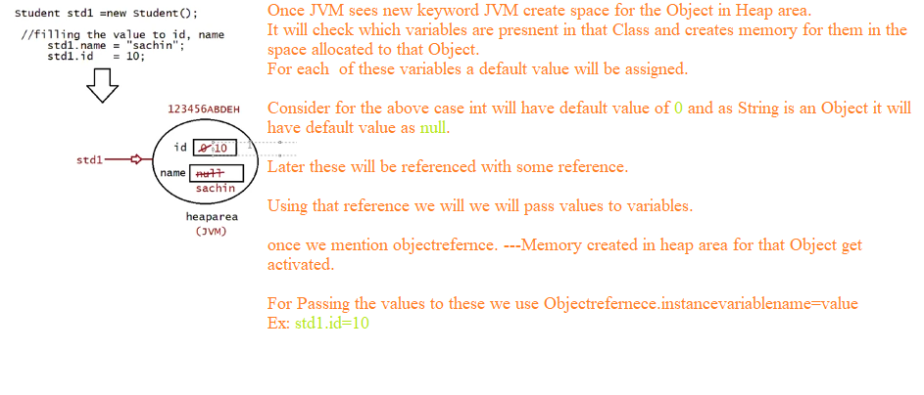

When the Memory for the instance variable will be created:

Once the Object is created JVM will create a memory for instance variable and by default JVM will assign default values to these variables based on the datatype of Variable

Ex: int à0

float à0.0f

char àSpace

booleanàfalse

String à null

The scope of instance variable would be available only when we have reference pointing to the Object .If the Object reference becomes null, we cant access “instance variables”

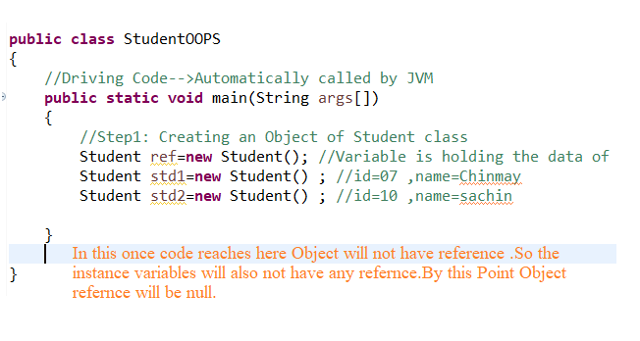

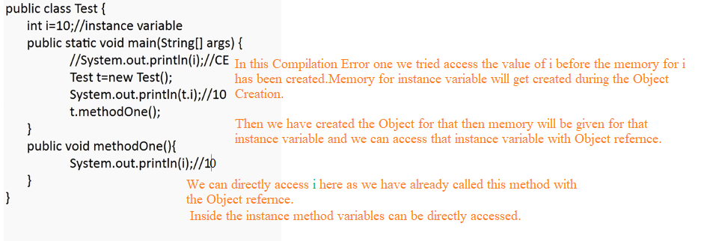

Local Variable:

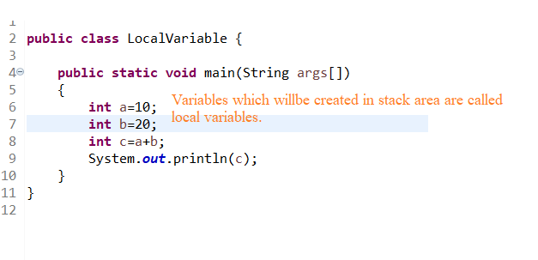

1.During the execution of the method the memory for the local variables will be given and after the execution of the method the memory for the variables will be taken out from the stack.

2.For local variables default value will not be given by JVM. If the programmers doesn’t specify the value program and using it would result in “CE” (It will result in CE only if the variable is used somewhere in program for some operations).

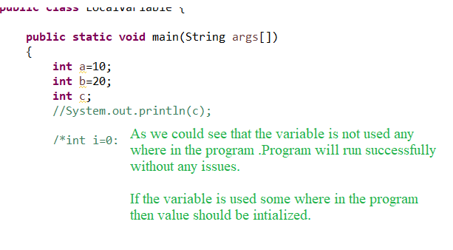

3.Variables which are created inside the method are called local variables, memory for them will in the stack area.

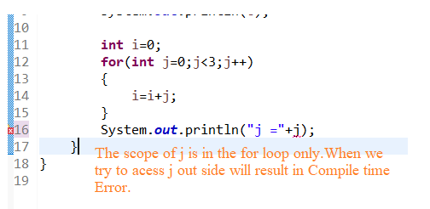

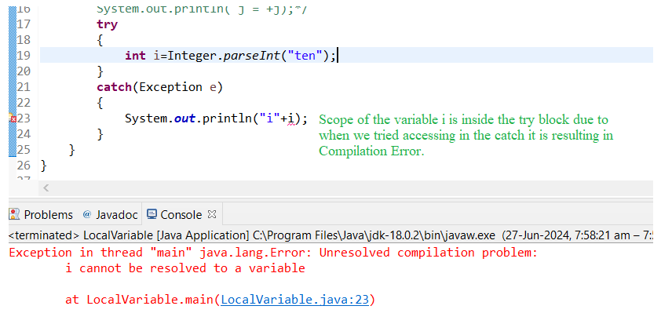

Variables declared inside method/block/constructor such type of variables are called local variables.

